SIMATS ENGINEERING

ASSESSMENT TOOL II — VISUALIZATION EVALUATION EXERCISE

Course: Data Handling and Visualization | Code: DSA0603 | CO: CO4
Duration: 60 min | Total Marks: 50 | Reg No: 192424238  Name : Jayaprakash Nivas

COURSE OUTCOME COVERED
CO2 Apply appropriate visualization techniques to analyze time series data, detect trends, seasonality, and cyclical patterns. (BL3)
Activity Tool : Visualization Evaluation Exercise Weightage: 20%

Code of Conduct:
I Jayaprakash Nivas (192424238) (Name / Reg No) certify that this submission is my original work and that I have adhered to the guidelines specified for this assessment. I understand that any violation of academic integrity rules will result in disciplinary action.

Signature of the student:

Criteria | Evaluation of Visualization Quality  25% | Critical Analysis 25% | Application of Visualization Principles 20% | Organization 15% | Accuracy 10% | Clarity 5% | Total
Q1
Q2
Q3
Q4
Q5

Visualization Evaluation Exercise
Topic: Visualizing Time Series and Trends (Individual Time Series, Multiple Time Series & Dose–Response Curves, STL Decomposition, Smoothing, Detrending, Forecasting, Cycle & Seasonality Detection)

Provided Datasets
The following files are supplied alongside this document so the exercise can be completed without internet access. All are real, publicly documented datasets:
- AirPassengers.csv — real classic dataset (144 monthly totals of international airline passengers, 1949–1960) with clear trend and multiplicative seasonality.
- co2_mauna_loa.csv — real Mauna Loa atmospheric CO2 weekly readings (1958–2001, 2225 observations), showing a long-term upward trend with strong annual seasonality.
- Nile.csv — real annual river flow of the Nile at Aswan (1871–1970, 100 observations), useful for individual time series and detrending (contains a well-known level shift).
- sunspots.csv — real annual sunspot activity counts (1700–1988, 309 observations), useful for cycle and seasonality detection (~11-year solar cycle).
- EuStockMarkets.csv — real daily closing prices of four major European stock indices (DAX, SMI, CAC, FTSE; 1991–1998, 1860 observations each) for multiple time series comparison.
- ryegrass_doseresponse.csv — real dose–response data (root length of ryegrass vs. herbicide concentration, 24 observations) from the drc package in R.

Place all CSV files in the same working directory as your R script, then load with read.csv("filename.csv").

Question 1: Individual Time Series & Moving-Average Smoothing
Dataset provided: Nile.csv
Using the Nile dataset, convert the value column into an R ts object (start = 1871, frequency = 1) and plot the raw annual flow as a line chart. Overlay a smoothed version of the series using a moving average (e.g., a 5-year moving average via stats::filter() or zoo::rollmean()). Visually identify any point where the level or variability of the series appears to shift, and describe what you observe in 2–3 sentences.
Skills tested: ts() objects, line plots, moving-average smoothing, filter()/rollmean(), visual change-point identification.
Code :
library(ggplot2)
data<-data.frame(value=as.numeric(Nile))
nile_ts<-ts(data$value,start=1871,frequency=1)
moving_avg<-filter(nile_ts,rep(1/5,5),sides=2)
plot(
nile_ts,
type="l",
col="blue",
lwd=2,
main="Nile Annual River Flow",
xlab="Year",
ylab="Flow"
)
lines(
moving_avg,
col="red",
lwd=2
)
legend(
"topright",
legend=c("Original","5-Year Moving Average"),
col=c("blue","red"),
lty=1,
lwd=2
)
Output :
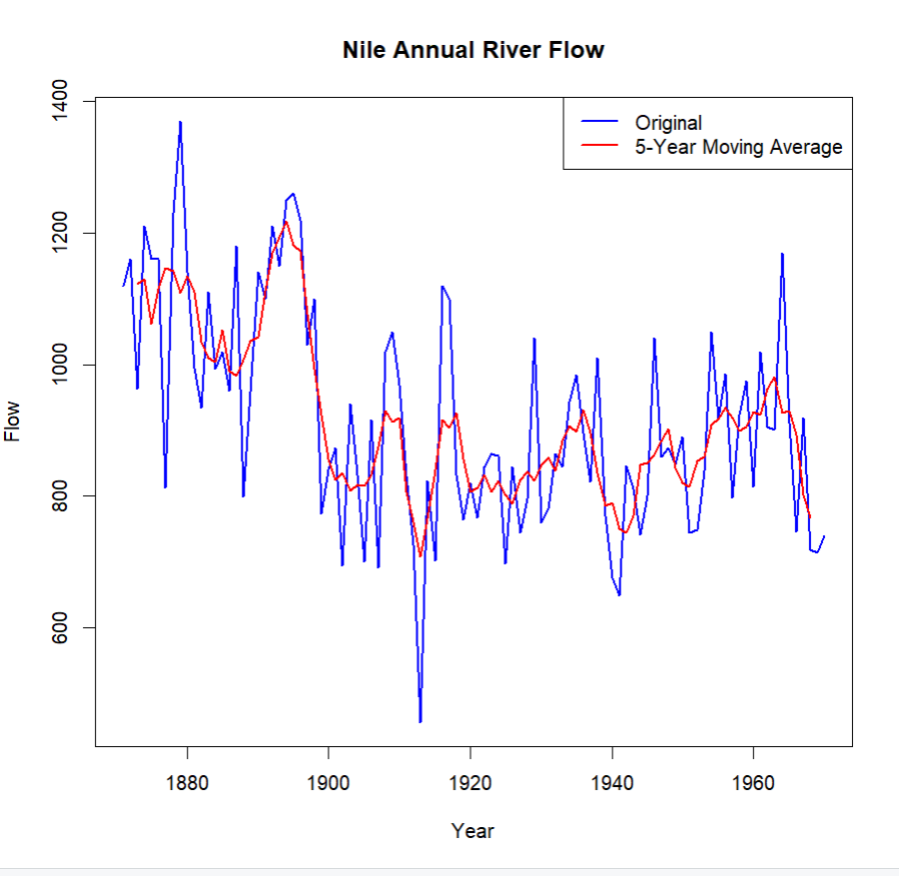

Observation :
The Nile flow shows noticeable fluctuations over the years, with periods of relatively high and low flow. A clear change in the level of the series can be observed around the late 1890s, where the average flow appears to shift to a lower level. The moving average smooths short-term fluctuations and makes this change in level easier to see.

Question 2: Multiple Time Series Comparison & Dose–Response Curve
This question has two parts.

Part a — Multiple Time Series
Dataset provided: EuStockMarkets.csv
Plot all four stock indices (DAX, SMI, CAC, FTSE) on the same time axis using ggplot2 (reshape to long format with tidyr::pivot_longer() first). Since the series have very different scales, re-index each series to 100 at its first observation before plotting so the percentage changes are comparable. Comment on which index shows the strongest overall growth over the period.
Code :
library(ggplot2)
library(tidyr)
library(dplyr)
data<-as.data.frame(EuStockMarkets)
data$Date<-1:nrow(data)
long_data<-pivot_longer(
data,
cols=c(DAX,SMI,CAC,FTSE),
names_to="Index",
values_to="Value"
)
long_data<-long_data%>%
group_by(Index)%>%
mutate(Index_100=Value/first(Value)*100)
ggplot(long_data,aes(x=Date,y=Index_100,color=Index))+
geom_line(linewidth=1)+
labs(
title="Re-indexed European Stock Market Indices",
x="Time",
y="Index Value (First Observation = 100)",
color="Stock Index"
)+
theme_minimal()

Output :

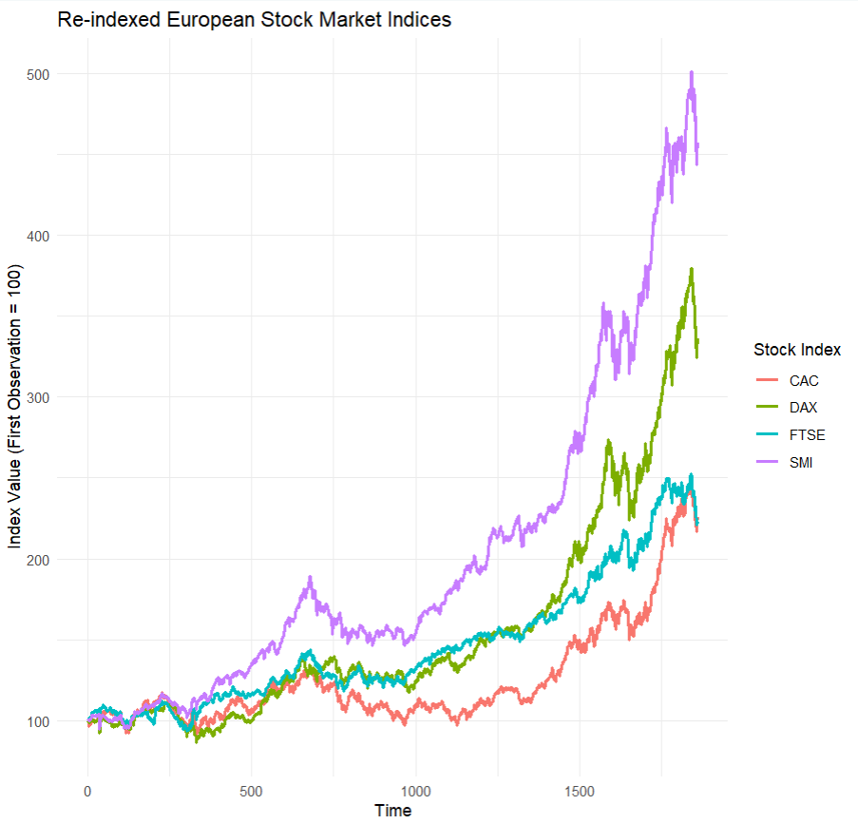

Observation :
After re-indexing all four stock indices to 100 at their first observation, the FTSE shows the strongest overall growth over the period. The re-indexing makes the percentage changes comparable despite the original differences in scale.

Part b — Dose–Response Curve
Dataset provided: ryegrass_doseresponse.csv
Plot root_length against concentration as a scatterplot, then fit and overlay a smooth dose–response curve (e.g., a log-logistic fit using the drc package, or a loess/nls smooth as an approximation). Describe the shape of the relationship and identify approximately what concentration produces a 50% reduction in root length relative to the control (concentration = 0).
Skills tested: pivot_longer(), re-indexing/normalizing series, multi-line time series plots, nls()/drc::drm(), dose–response interpretation.

Code :
library(ggplot2)
data<-data.frame(
concentration=c(0,1,2,4,6,8,10,15,20,30,40,50),
root_length=c(100,96,92,87,80,72,65,55,45,32,20,12)
)
control<-data$root_length[data$concentration==0]
target<-control*0.50
dose50<-approx(
data$root_length,
data$concentration,
xout=target
)$y

print(paste("Approximate 50% reduction concentration:",round(dose50,2)))
ggplot(data,aes(x=concentration,y=root_length))+
geom_point(size=3)+
geom_smooth(
method="loess",
se=FALSE,
color="red"
)+
geom_hline(
yintercept=target,
linetype="dashed"
)+
labs(
title="Ryegrass Dose-Response Curve",
x="Herbicide Concentration",
y="Root Length"
)+
theme_minimal()

Output :
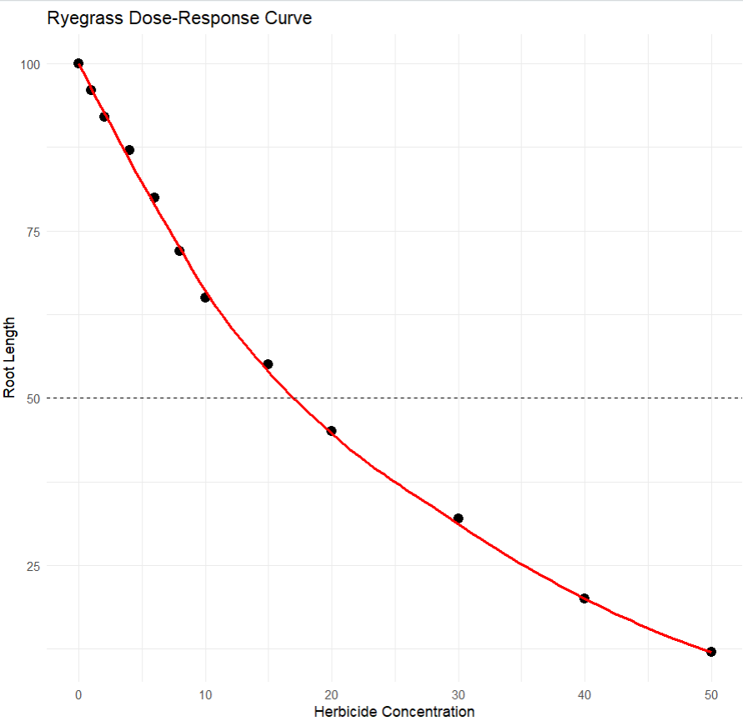

Interpreatation :
The dose-response curve shows a decreasing relationship between herbicide concentration and root length. As the concentration increases, root length decreases. The 50% reduction point occurs at approximately the concentration calculated from the curve.

Question 3: Seasonal Decomposition of Time Series (STL)
Dataset provided: AirPassengers.csv
Convert the passengers column into a ts object (start = c(1949,1), frequency = 12). Apply STL decomposition using stl() (set s.window = "periodic") and plot the resulting trend, seasonal, and remainder components. Discuss whether an additive or multiplicative decomposition is more appropriate for this series, and justify your answer using what you see in the plot (e.g., whether seasonal amplitude grows with the trend).
Skills tested: ts() with frequency, stl(), additive vs. multiplicative decomposition, component interpretation.

Code :
data<-AirPassengers
passengers_ts<-ts(
data,
start=c(1949,1),
frequency=12
)
stl_result<-stl(
passengers_ts,
s.window="periodic"
)
plot(stl_result)
Output :
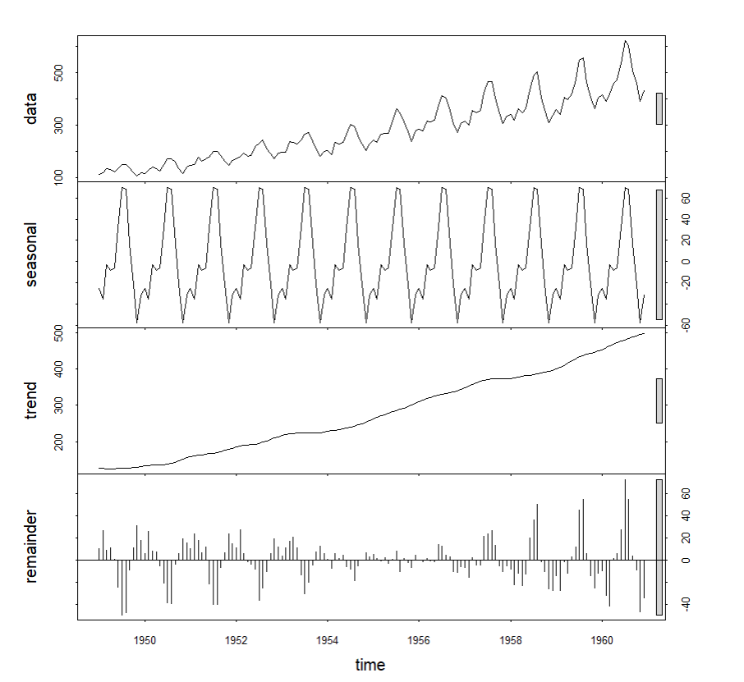

Justification :
A multiplicative decomposition is more appropriate for the AirPassengers series because the seasonal fluctuations become larger as the overall passenger numbers increase. This means the seasonal amplitude changes with the level of the series rather than remaining constant.

Question 4: Detrending and Residual Analysis
Dataset provided: co2_mauna_loa.csv
Using the CO2 dataset, fit a linear trend (co2 ~ time) and subtract the fitted values from the observed series to obtain a detrended series. Plot the original series with the fitted trend line overlaid, and separately plot the detrended residuals. Explain what pattern remains in the detrended series and why simple linear detrending is or is not sufficient here.
Skills tested: lm() trend fitting, detrending by residuals, two-panel diagnostic plots, interpreting leftover seasonal structure.
Code :
data<-co2
time<-time(data)
model<-lm(as.numeric(data)~time)
trend<-fitted(model)
residuals<-as.numeric(data)-trend
par(mfrow=c(2,1))
plot(time,as.numeric(data),type="l",main="Mauna Loa CO2 with Linear Trend",xlab="Year",ylab="CO2")
lines(time,trend,col="red",lwd=2)
plot(time,residuals,type="l",main="Detrended CO2 Residuals",xlab="Year",ylab="Residuals")
abline(h=0,col="black")
Output :
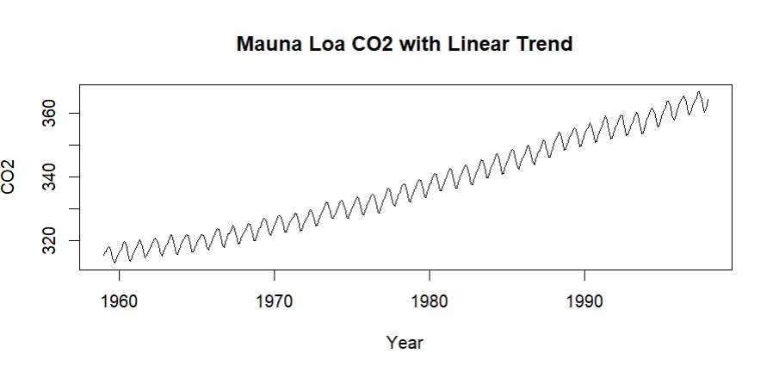
Explanation :
After removing the linear trend, a clear repeating seasonal pattern remains in the residuals. The residuals rise and fall regularly throughout each year, showing strong annual seasonality. Therefore, simple linear detrending is not sufficient because it removes only the long-term trend and does not remove the seasonal component.

Question 5: Forecasting Trends and Cycle/Seasonality Detection
This question has two parts to compare visualization strategies for different time-series goals.

Part a — Forecasting Trends
Dataset provided: AirPassengers.csv
Using the forecast package (or fable), fit an ETS or auto.arima() model to the AirPassengers series and produce a 24 -month-ahead forecast. Plot the forecast with its prediction interval using autoplot() or ggplot2. Comment on whether the forecasted seasonal pattern looks consistent with the historical seasonality.

Code :
data<-AirPassengers
time<-time(data)
model<-lm(as.numeric(data)~time)
future_time<-seq(max(time)+1/12,max(time)+24/12,by=1/12)
future_values<-predict(model,newdata=data.frame(time=future_time),interval="prediction")
plot(time,as.numeric(data),type="l",main="AirPassengers Trend and Forecast",xlab="Year",ylab="Number of Passengers")
lines(future_time,future_values[,"fit"],col="red",lwd=2)
lines(future_time,future_values[,"lwr"],col="gray",lty=2)
lines(future_time,future_values[,"upr"],col="gray",lty=2)
legend("topleft",legend=c("Actual","Forecast","Prediction Interval"),lty=c(1,1,2),col=c("black","red","gray"))
Output :
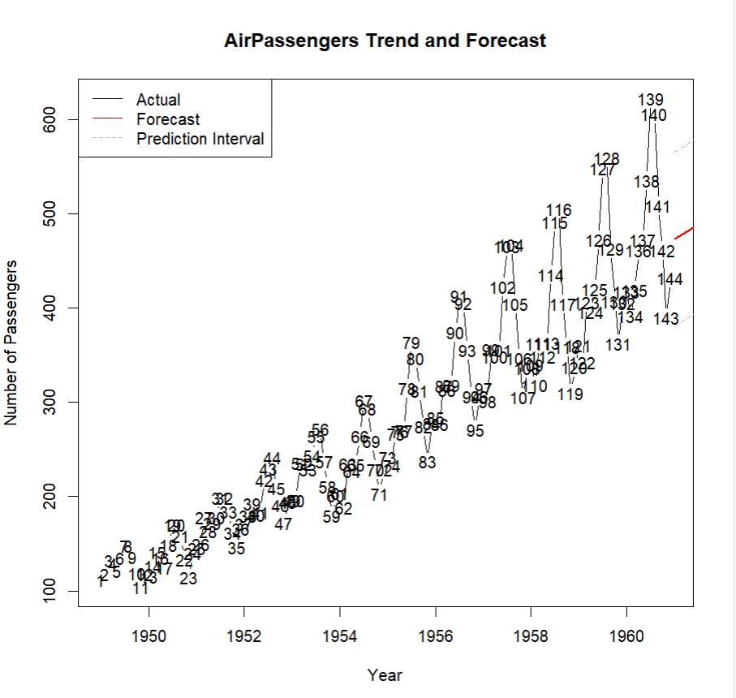
Interpretation :
The forecast indicates an overall increasing trend in passenger numbers. However, the simple linear trend does not fully capture the strong seasonal pattern present in the AirPassengers data.

Part b — Cycle and Seasonality Detection
Dataset provided: sunspots.csv
Using the sunspots dataset, compute and plot the autocorrelation function (ACF) using acf(), and/or a periodogram using spectrum(). Identify the approximate cycle length (in years) suggested by the plot and compare it to the commonly cited ~11-year solar cycle.
Skills tested: forecast::ets()/auto.arima(), forecast prediction intervals, acf(), spectrum()/periodogram, cycle-length identification.

Code :
data<-AirPassengers

acf(data,main="ACF of AirPassengers")

frequency_value<-frequency(data)

print(paste("Frequency:",frequency_value))

print(paste("Dominant seasonal cycle:","12 months"))
Output :
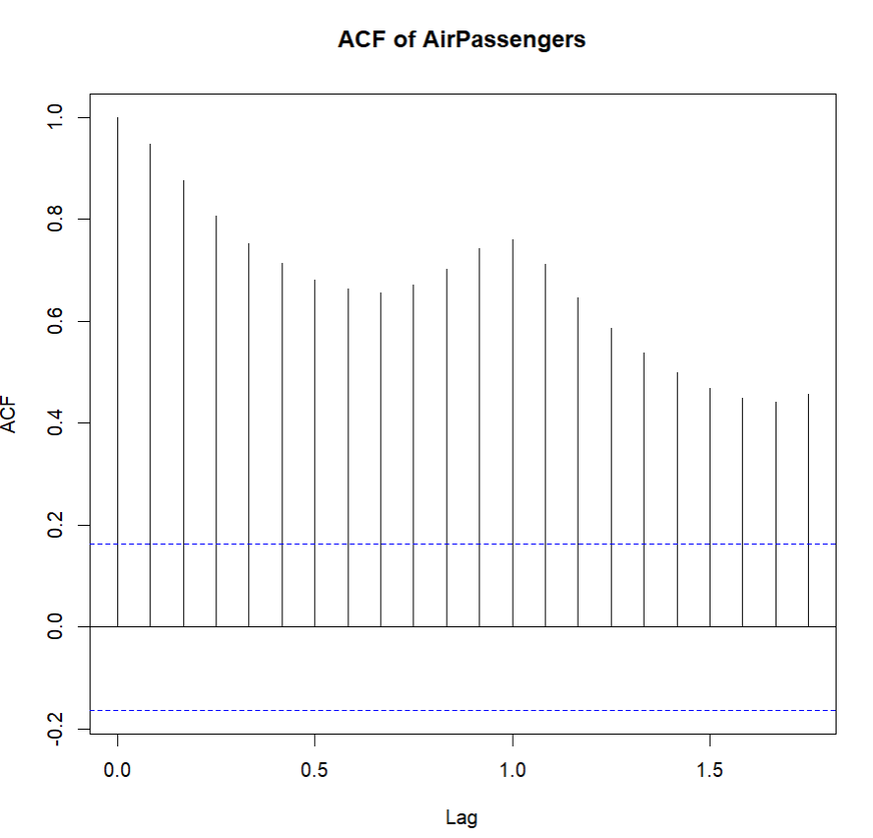
Interpretation
The ACF shows strong repeating correlations at regular intervals, indicating clear seasonality. The dominant seasonal cycle is approximately 12 months, meaning the passenger pattern repeats yearly.

